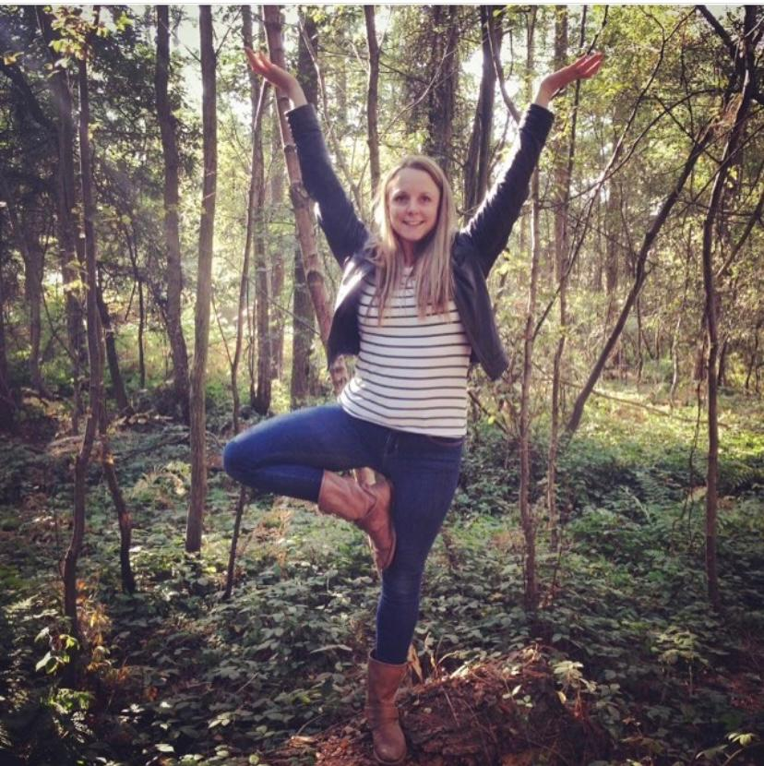 |  | Yoga  I’m Sasha; yoga and meditation teacher and lover of the great outdoors, passionate about promoting health and happiness through movement, mindful living and connection with nature.  I teach yoga and meditation here in beautiful Shropshire as well as around the UK on residential retreats. I work with people of all ages (from schools to retirement homes and everything in between) and all levels of yoga experience. I am available to offer ‘bolt-on’ for your stay at Wild contentment in a way that suits you and your party.  - Private 1:1 session  - A family session  - Children’s classes  - From 1hr sessions right through to whole day ‘retreat style’  Sessions can be held in the great outdoors or undercover in the Party Shed at the farm.  Please do get in tough to have a chat about how I can help you make the most of your stay.  07557991805  Sasha.ford@hotmail.co.uk

